=======================================================

Application: kicad
Version: 6.0.0-rc1-unknown-a5c892d~84~ubuntu14.04.1, release build
[GS note: commit a5c892d9cd36829b5288a29f1682f22a4c78830e was built 18 Oct. 2018 at 15:15:22]
Libraries:
wxWidgets 3.0.2
libcurl/7.35.0 OpenSSL/1.0.1f zlib/1.2.8 libidn/1.28 librtmp/2.3
Platform: Linux 4.4.0-112-generic x86_64, 64 bit, Little endian, wxGTK
Build Info:
wxWidgets: 3.0.2 (wchar_t,wx containers,compatible with 2.8) GTK+ 2.24
Boost: 1.54.0
OpenCASCADE Community Edition: 6.8.0
Curl: 7.35.0
Compiler: GCC 4.8.4 with C++ ABI 1002

Build settings:
USE_WX_GRAPHICS_CONTEXT=OFF
USE_WX_OVERLAY=OFF
KICAD_SCRIPTING=ON
KICAD_SCRIPTING_MODULES=ON
KICAD_SCRIPTING_WXPYTHON=ON
KICAD_SCRIPTING_ACTION_MENU=ON
BUILD_GITHUB_PLUGIN=ON
KICAD_USE_OCE=ON
KICAD_USE_OCC=OFF
KICAD_SPICE=ON

commit 47f0f52b28471a8be6e5fc28bd8407dbf9090f26

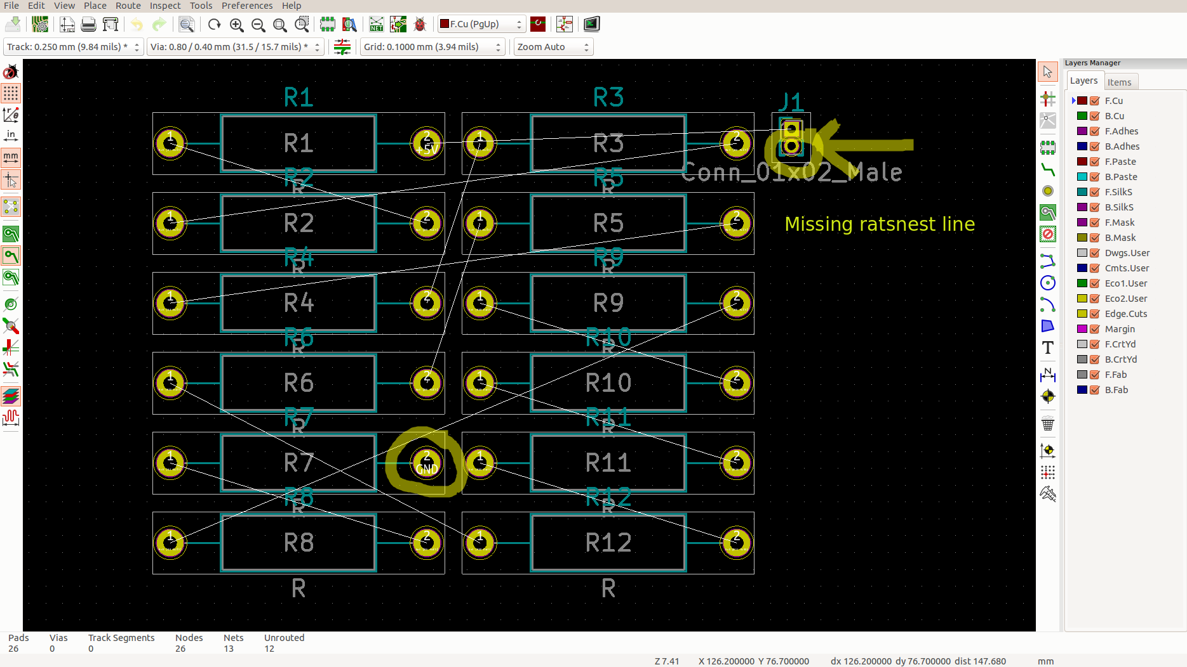

=======================================================

Application: kicad
Version: 5.0.0-fee4fd1~66~ubuntu14.04.1, release build
Libraries:f
wxWidgets 3.0.2
libcurl/7.35.0 OpenSSL/1.0.1f zlib/1.2.8 libidn/1.28 librtmp/2.3
Platform: Linux 4.4.0-112-generic x86_64, 64 bit, Little endian, wxGTK
Build Info:
wxWidgets: 3.0.2 (wchar_t,wx containers,compatible with 2.8) GTK+ 2.24
Boost: 1.54.0
OpenCASCADE Community Edition: 6.8.0
Curl: 7.35.0
Compiler: GCC 4.8.4 with C++ ABI 1002

Build settings:
USE_WX_GRAPHICS_CONTEXT=OFF
USE_WX_OVERLAY=OFF
KICAD_SCRIPTING=ON
KICAD_SCRIPTING_MODULES=ON
KICAD_SCRIPTING_WXPYTHON=OFF
KICAD_SCRIPTING_ACTION_MENU=ON
BUILD_GITHUB_PLUGIN=ON
KICAD_USE_OCE=ON
KICAD_USE_OCC=OFF
KICAD_SPICE=ON

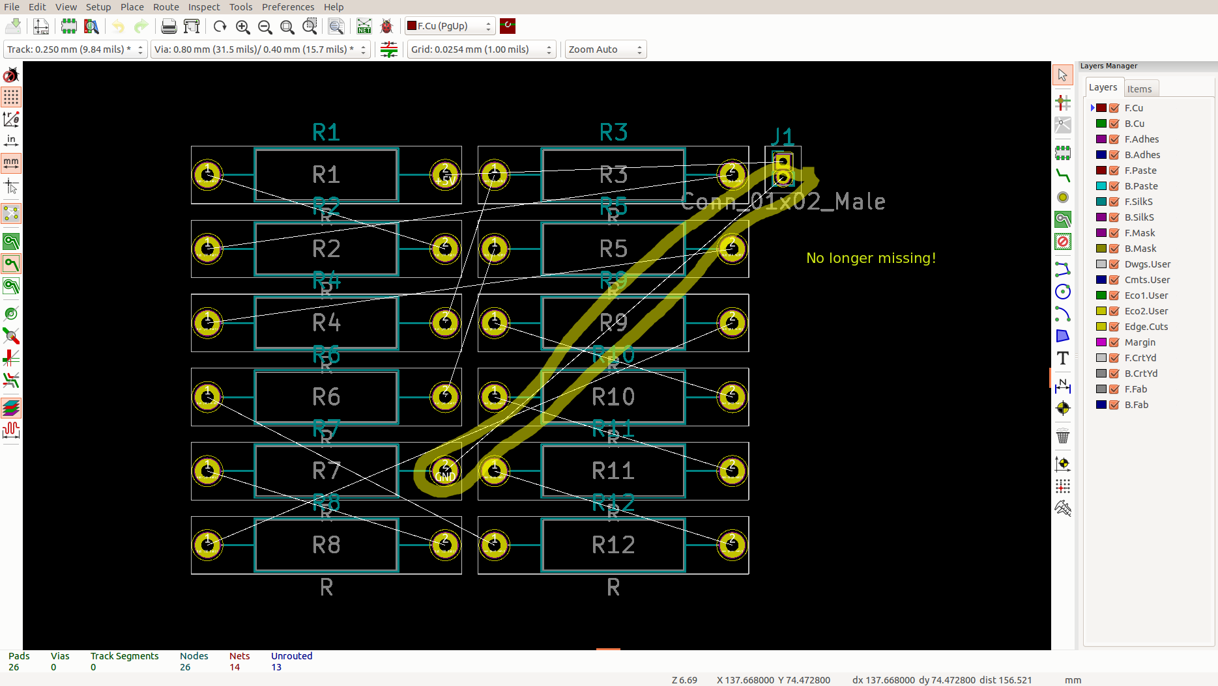

Nets:

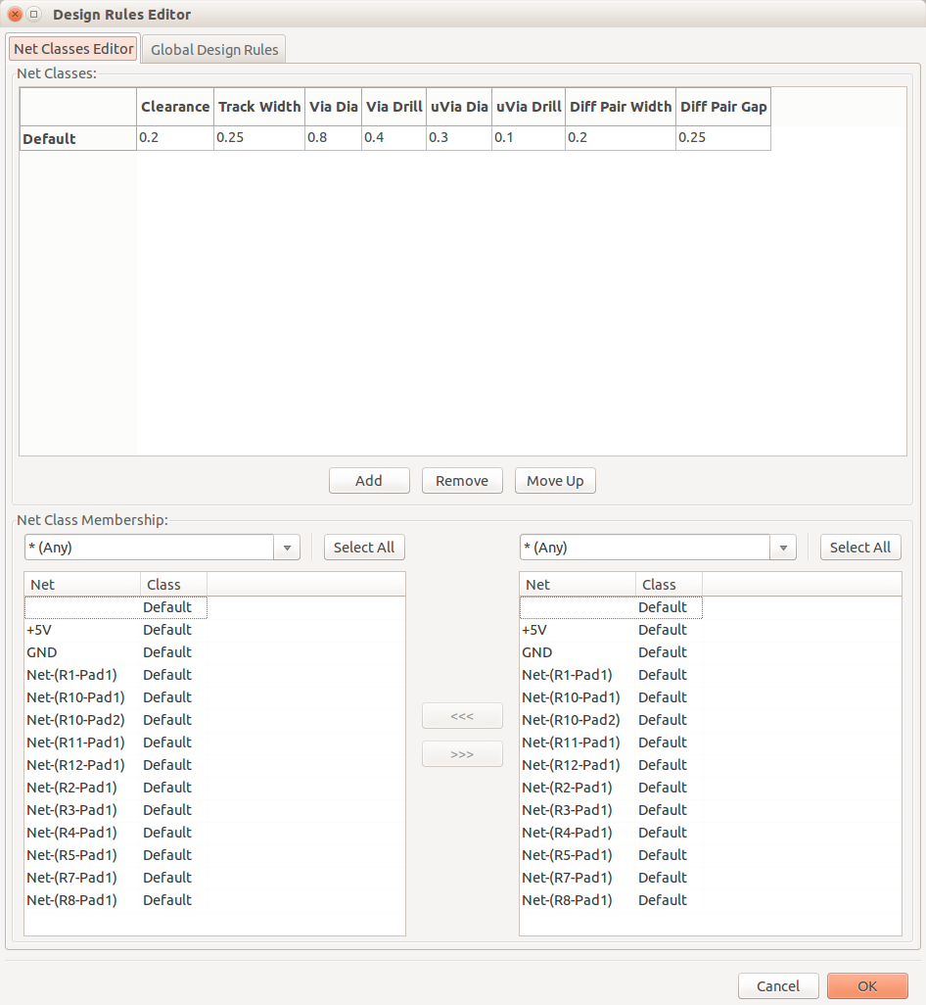

=======================================================

Application: kicad
Version: 6.0.0-rc1-unknown-82f657e~84~ubuntu14.04.1, release build
[GS note: 82f657ed036fd5fc3609c1baaf13f2449d77baaa was built 22 Nov 2018 at 01:09:40]
Libraries:
wxWidgets 3.0.2
libcurl/7.35.0 OpenSSL/1.0.1f zlib/1.2.8 libidn/1.28 librtmp/2.3
Platform: Linux 4.4.0-112-generic x86_64, 64 bit, Little endian, wxGTK
Build Info:
wxWidgets: 3.0.2 (wchar_t,wx containers,compatible with 2.8) GTK+ 2.24
Boost: 1.54.0
OpenCASCADE Community Edition: 6.8.0
Curl: 7.35.0
Compiler: GCC 4.8.4 with C++ ABI 1002

Build settings:
USE_WX_GRAPHICS_CONTEXT=OFF
USE_WX_OVERLAY=OFF
KICAD_SCRIPTING=ON
KICAD_SCRIPTING_MODULES=ON
KICAD_SCRIPTING_PYTHON3=OFF
KICAD_SCRIPTING_WXPYTHON=ON
KICAD_SCRIPTING_WXPYTHON_PHOENIX=OFF
KICAD_SCRIPTING_ACTION_MENU=ON
BUILD_GITHUB_PLUGIN=ON
KICAD_USE_OCE=ON
KICAD_USE_OCC=OFF
KICAD_SPICE=ON

Looks good! But...it has only 13 nets vs 14, what’s the difference? Ans: v5 counted an empty placeholder as a net, v6 has been fixed and doesn’t. Good!
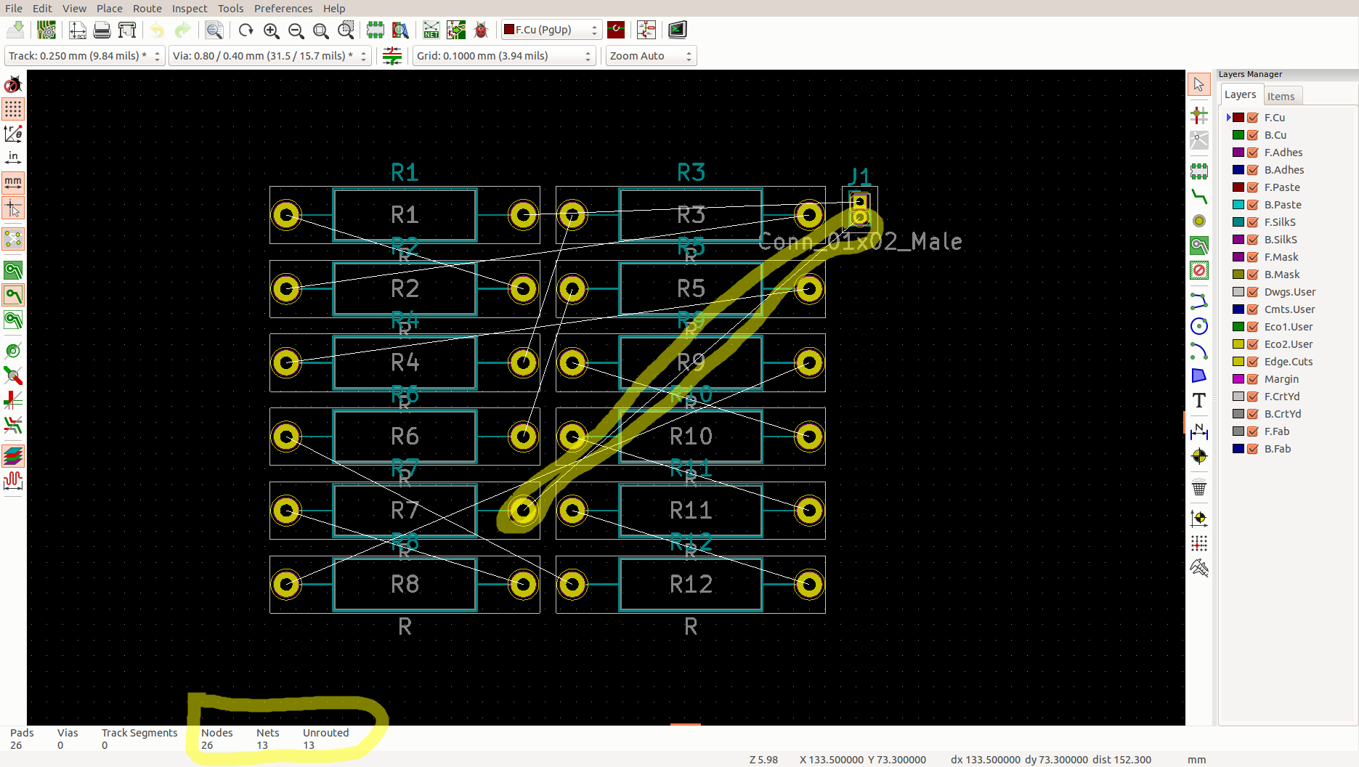

Here’s the nets:
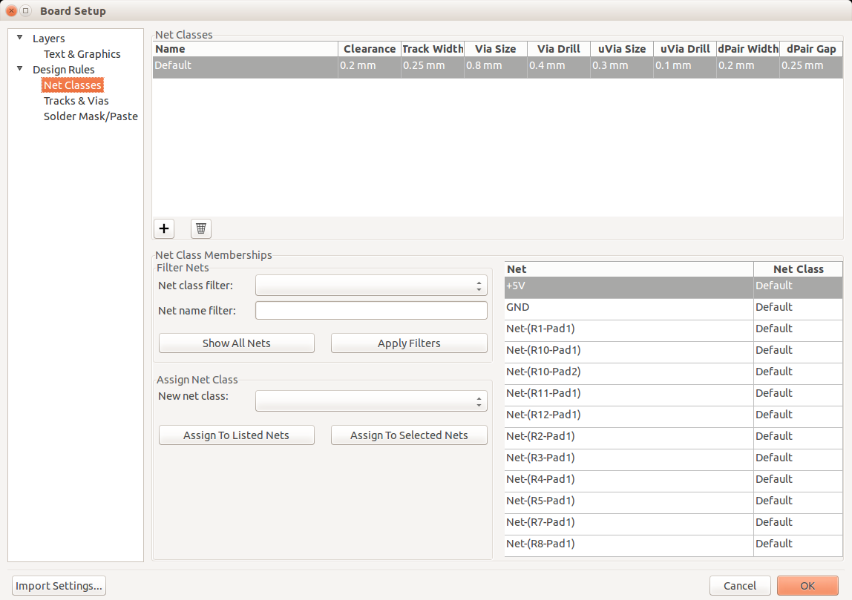

=======================================================

=======================================================

=======================================================

=======================================================

=======================================================

=======================================================

=======================================================

=======================================================

=======================================================

=======================================================

- D
- d
- d
- dd
- d
- d
- dd
- d
- d
- d
- d
- d
- d
- d

